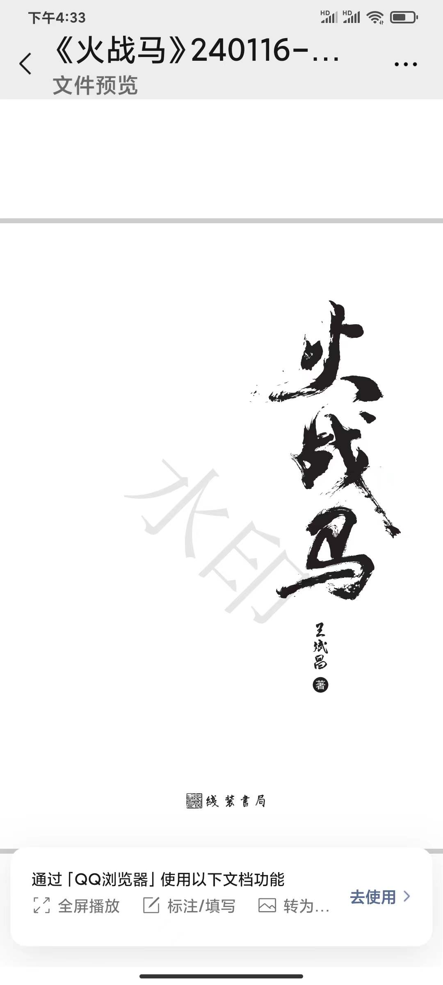

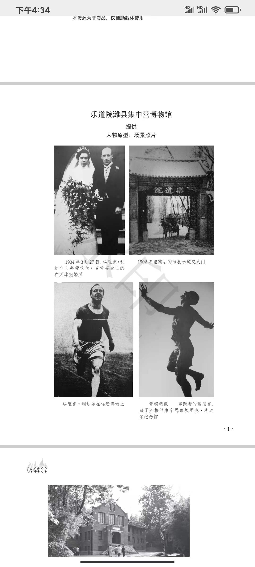
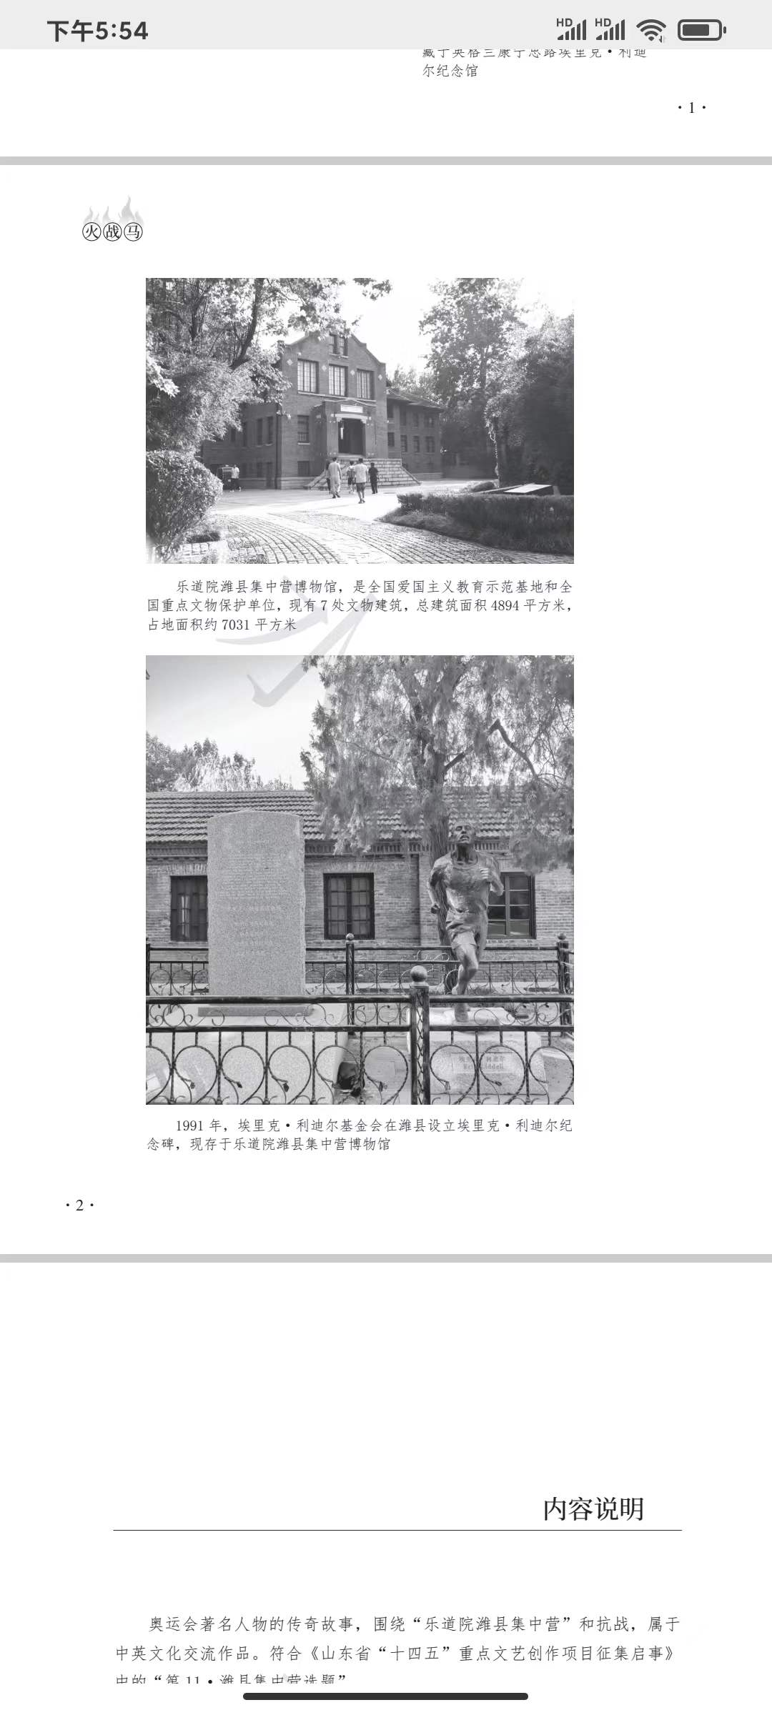
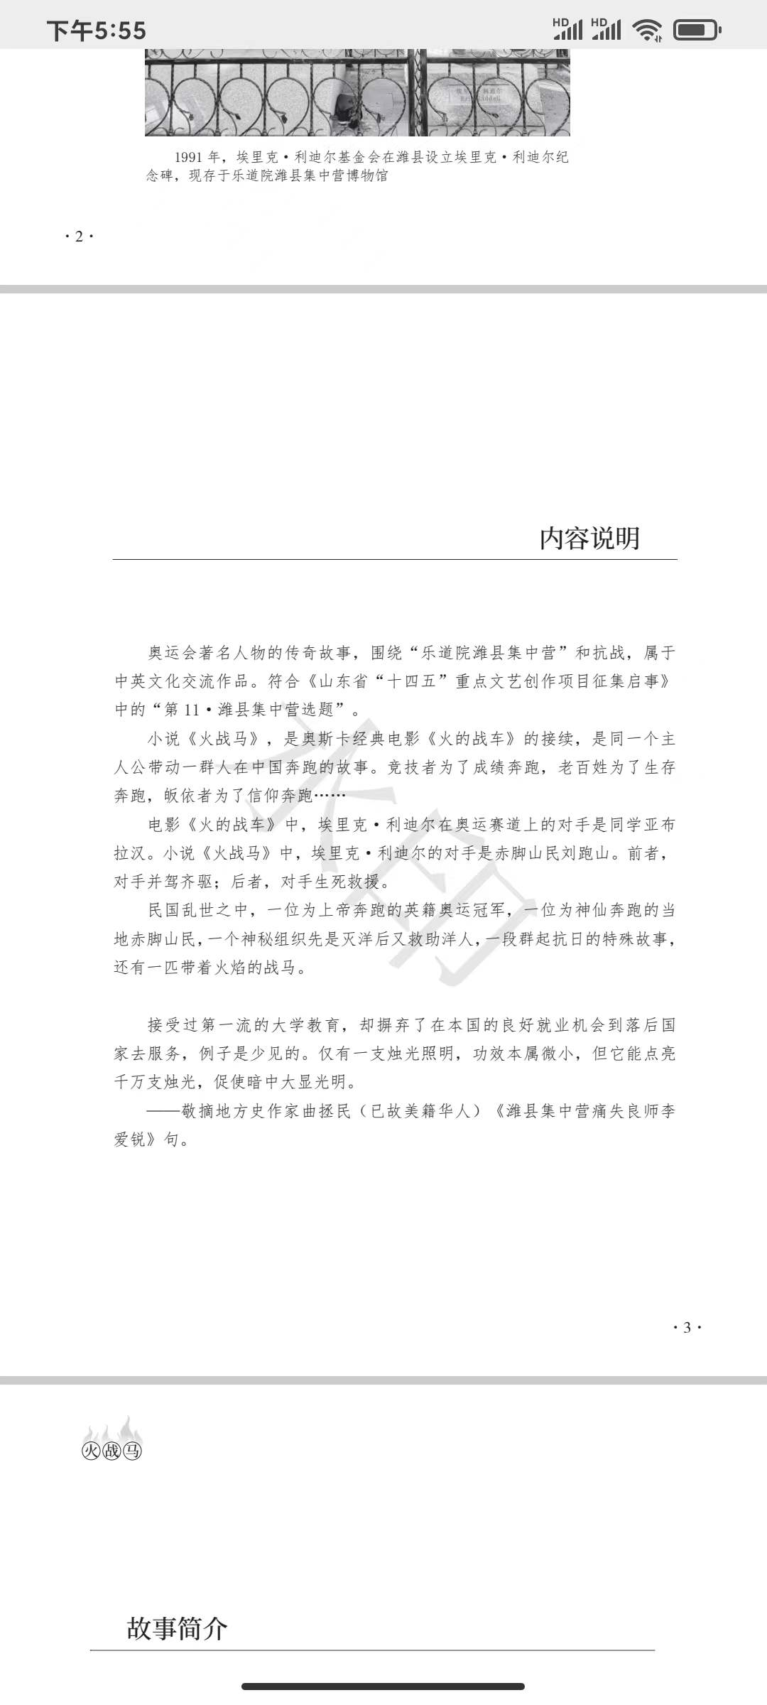

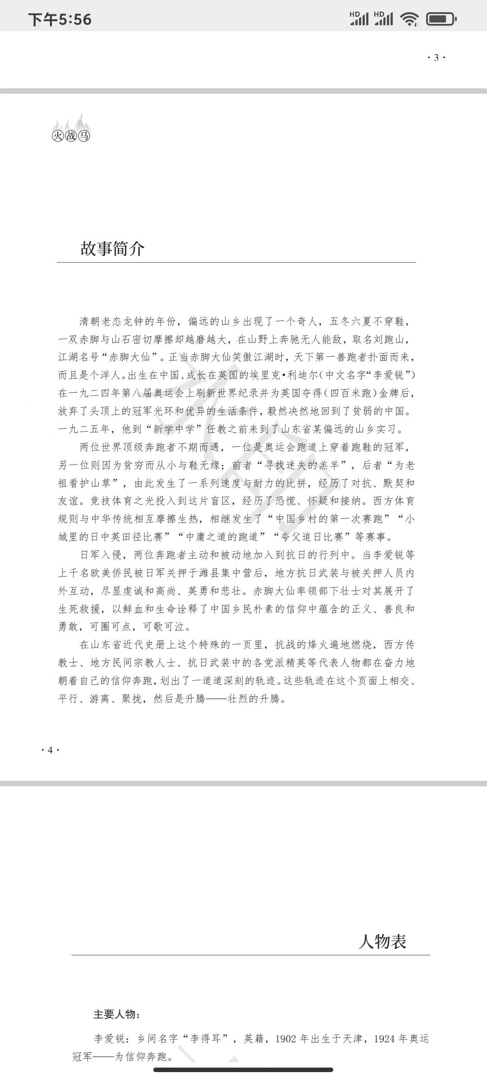

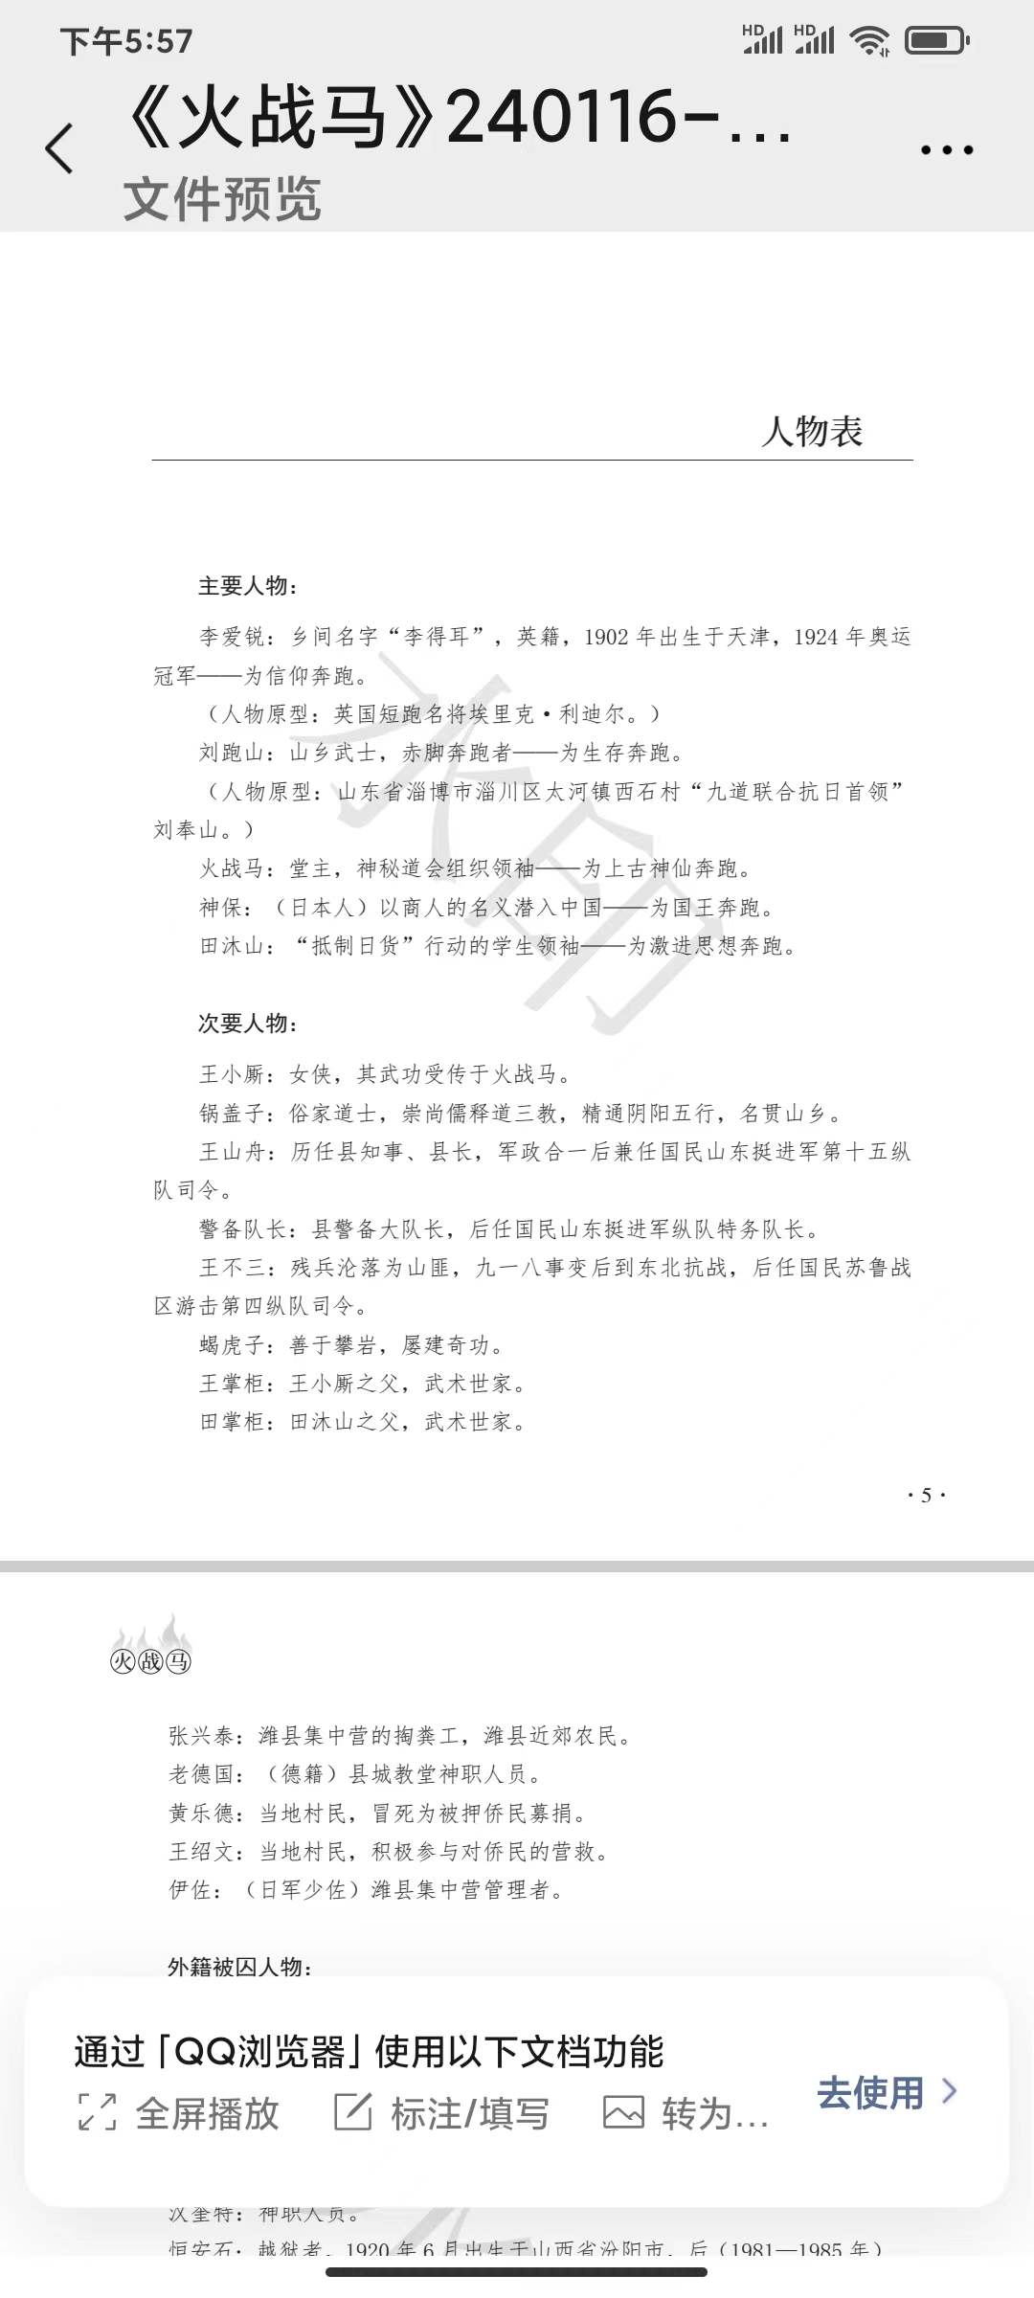

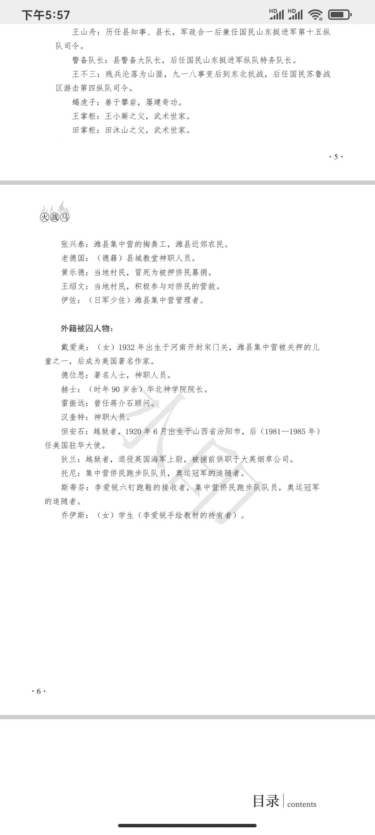

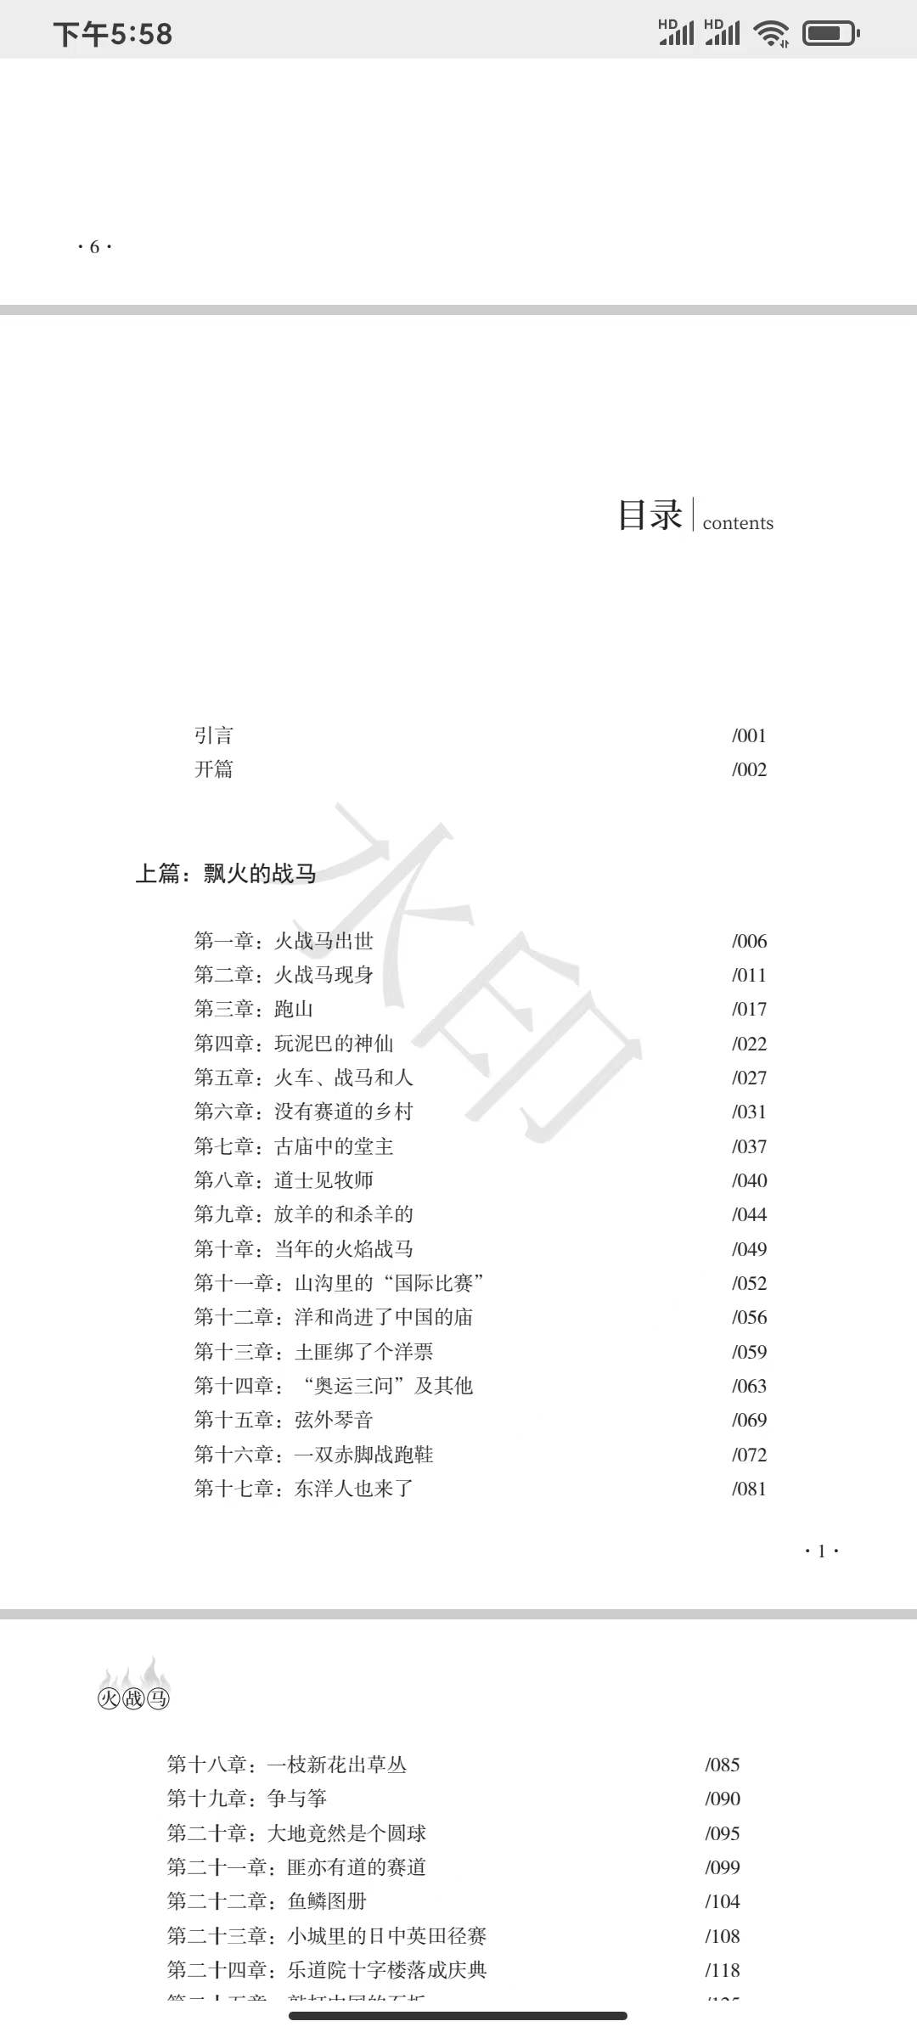

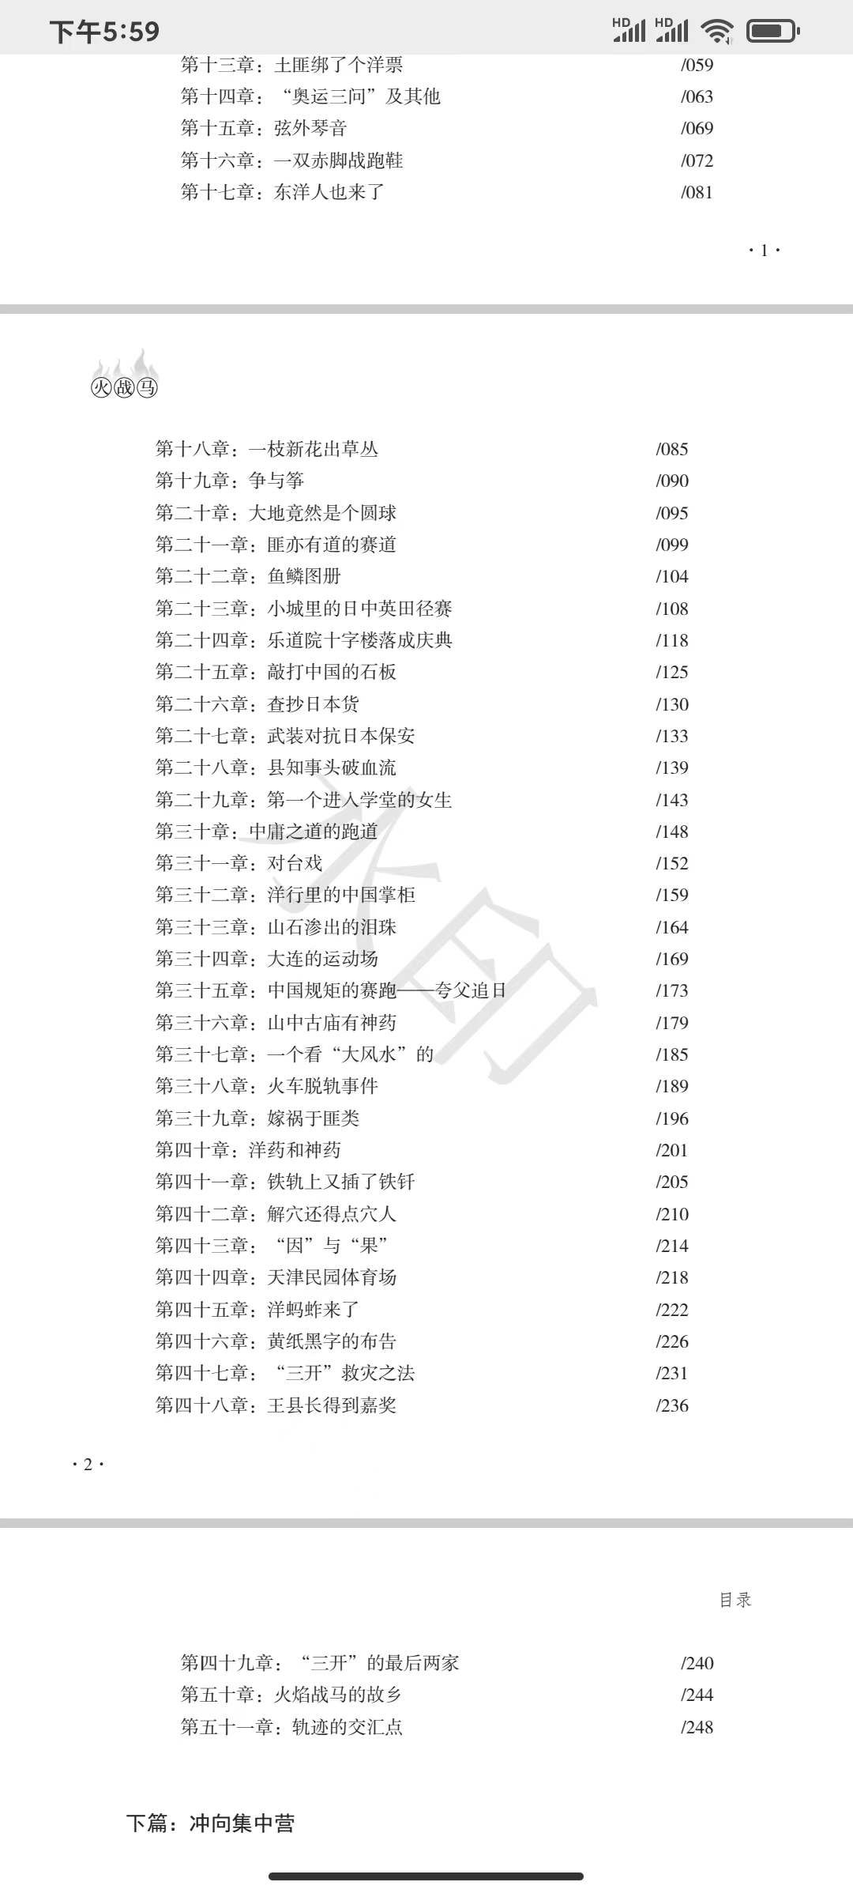

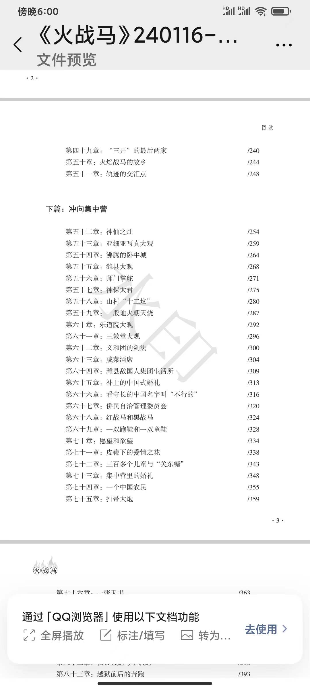

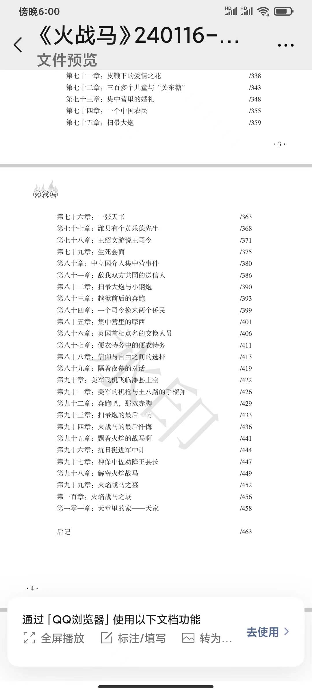

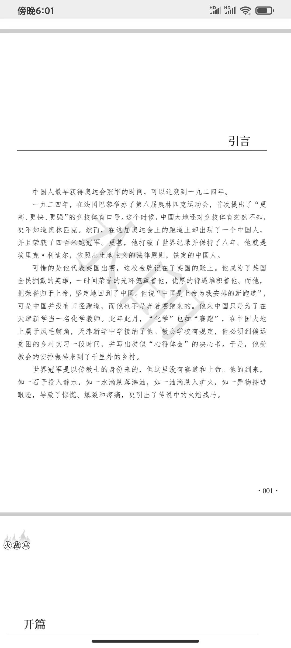

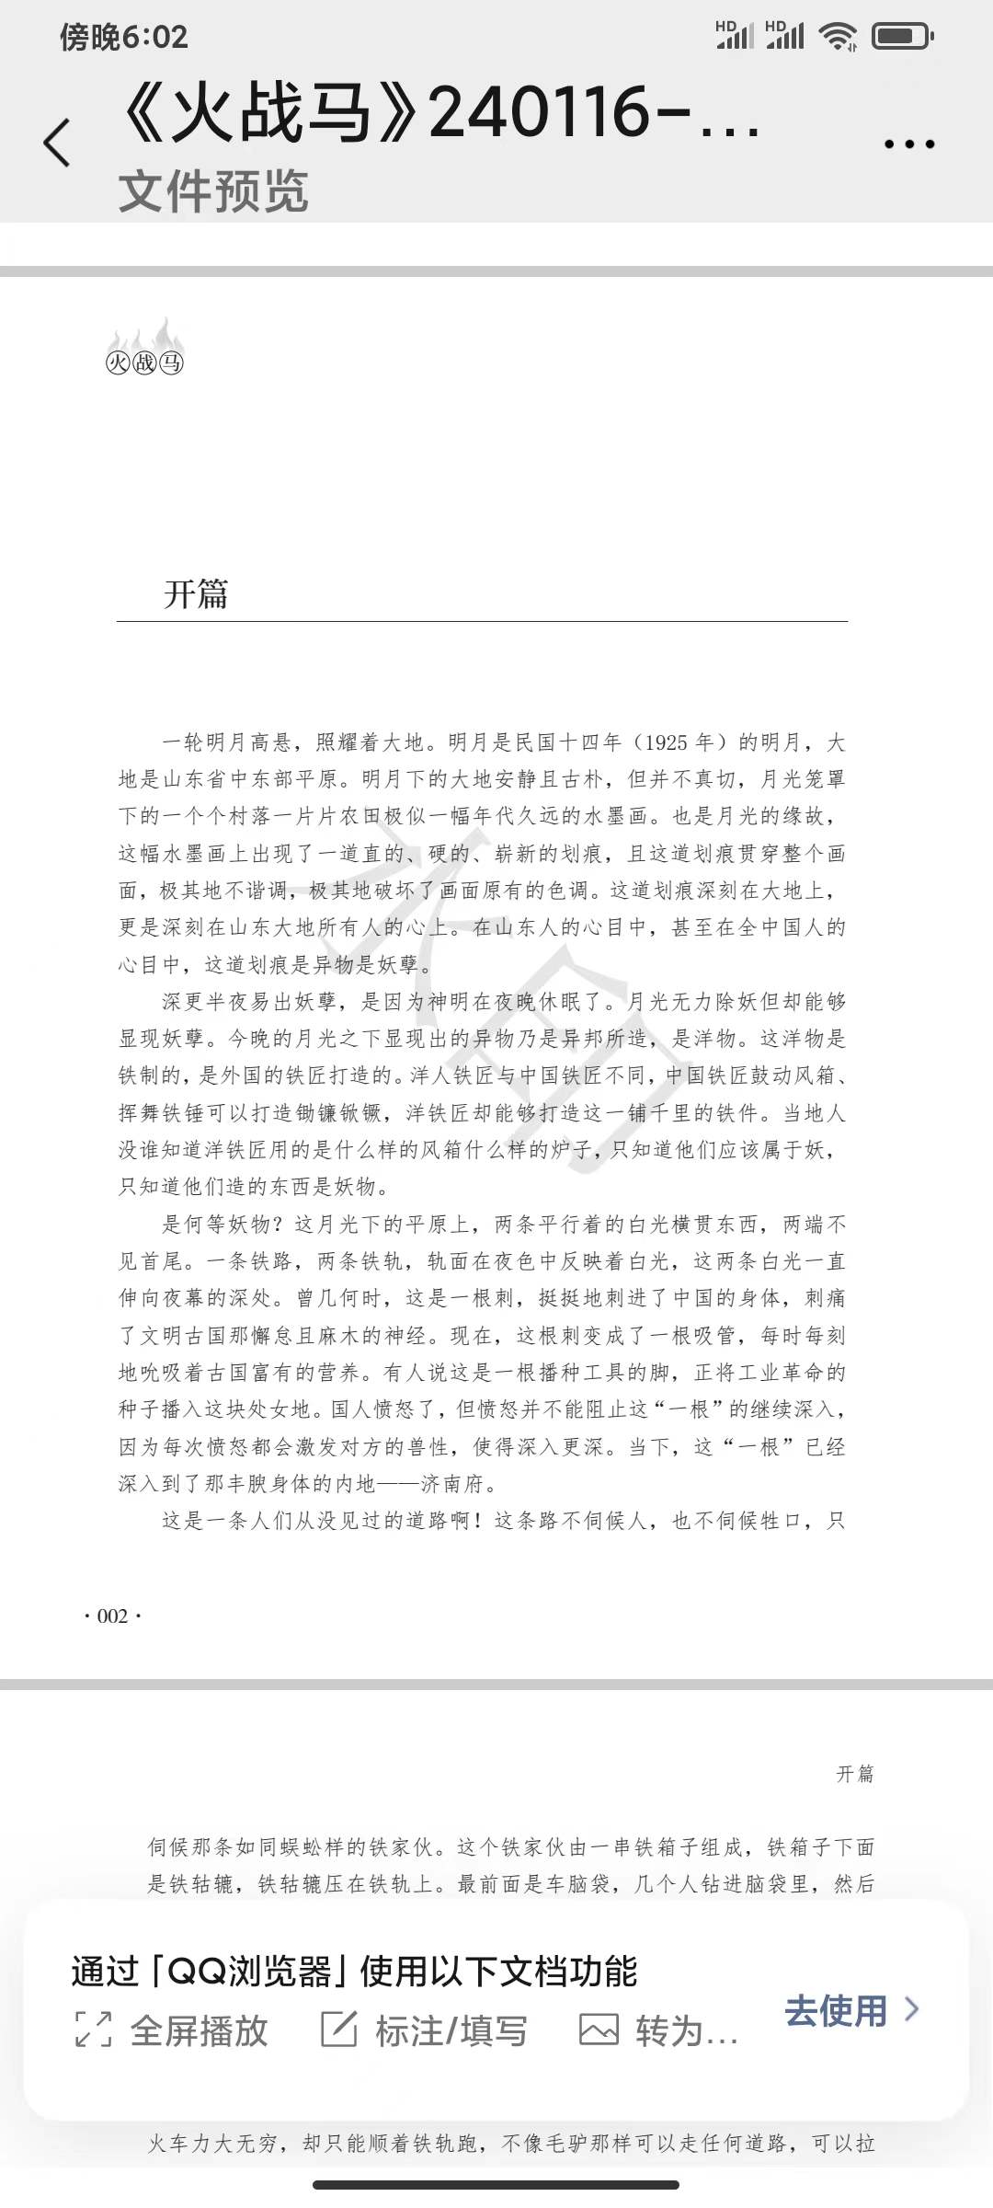

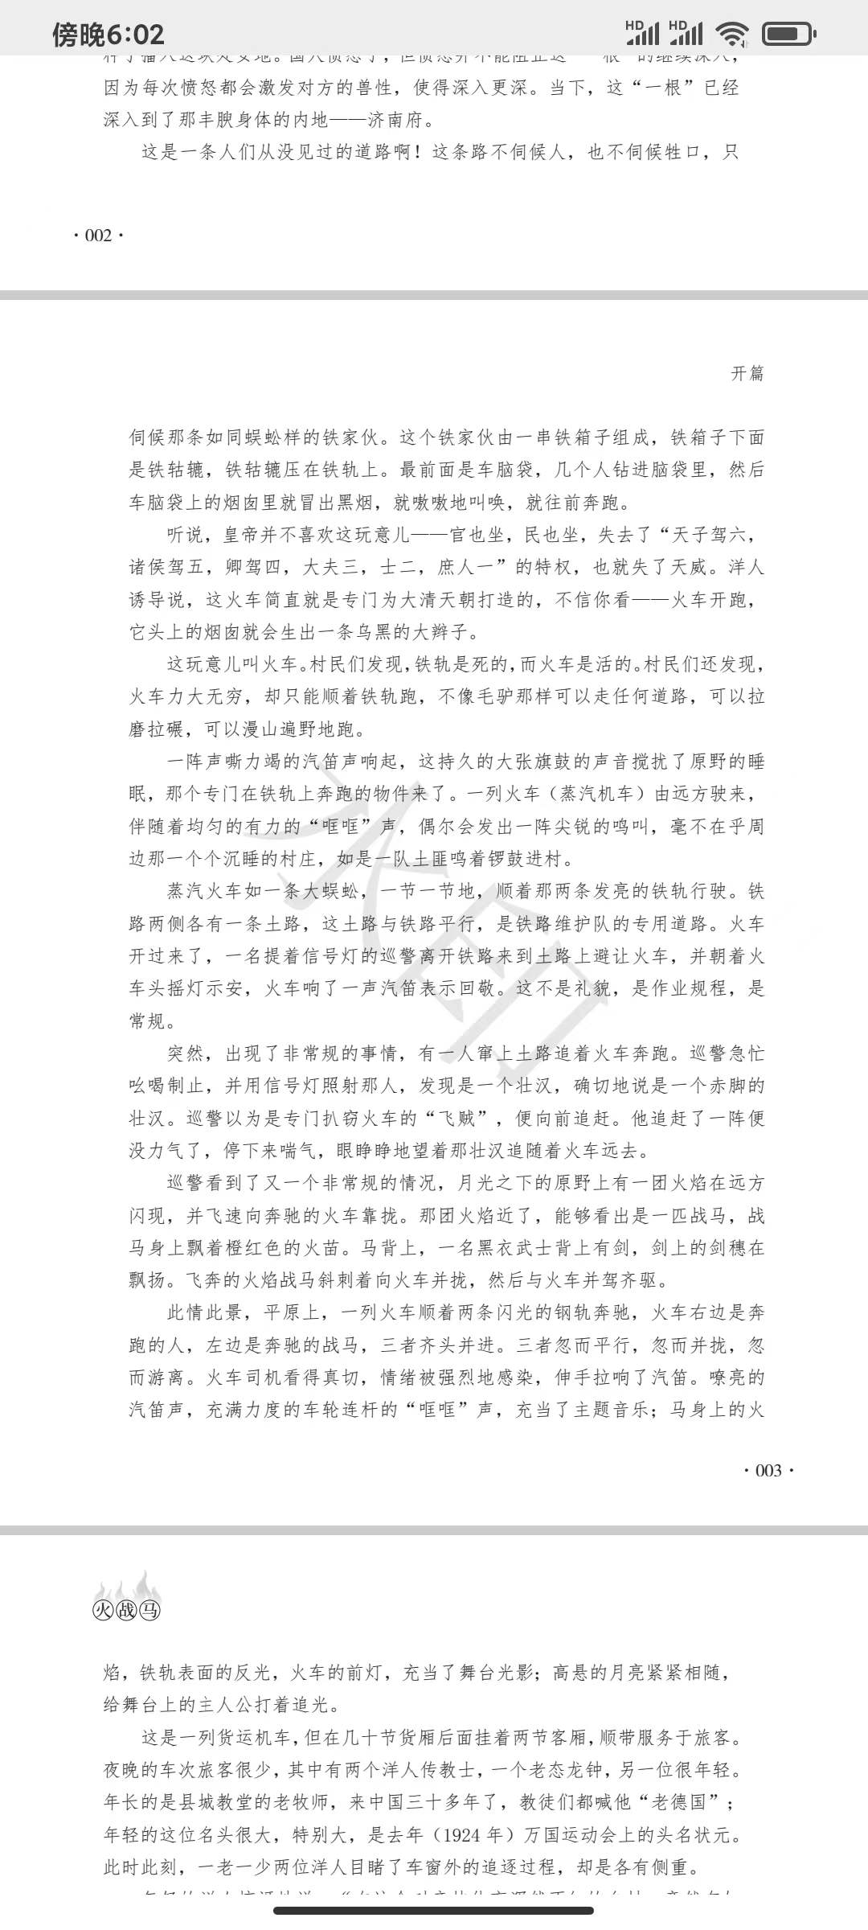

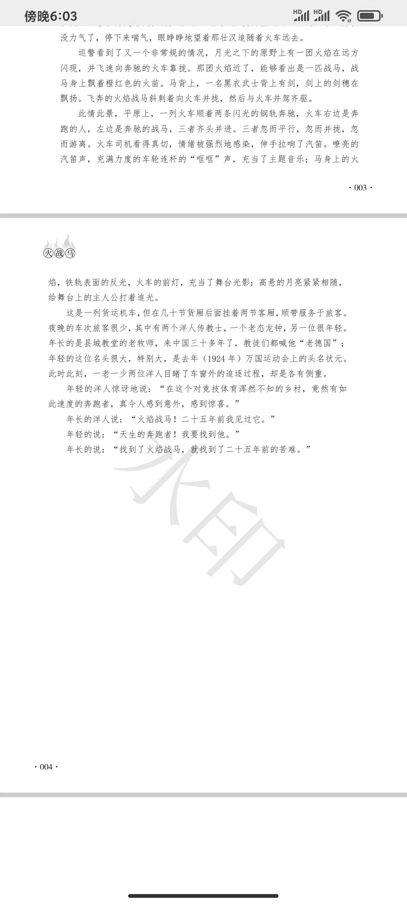

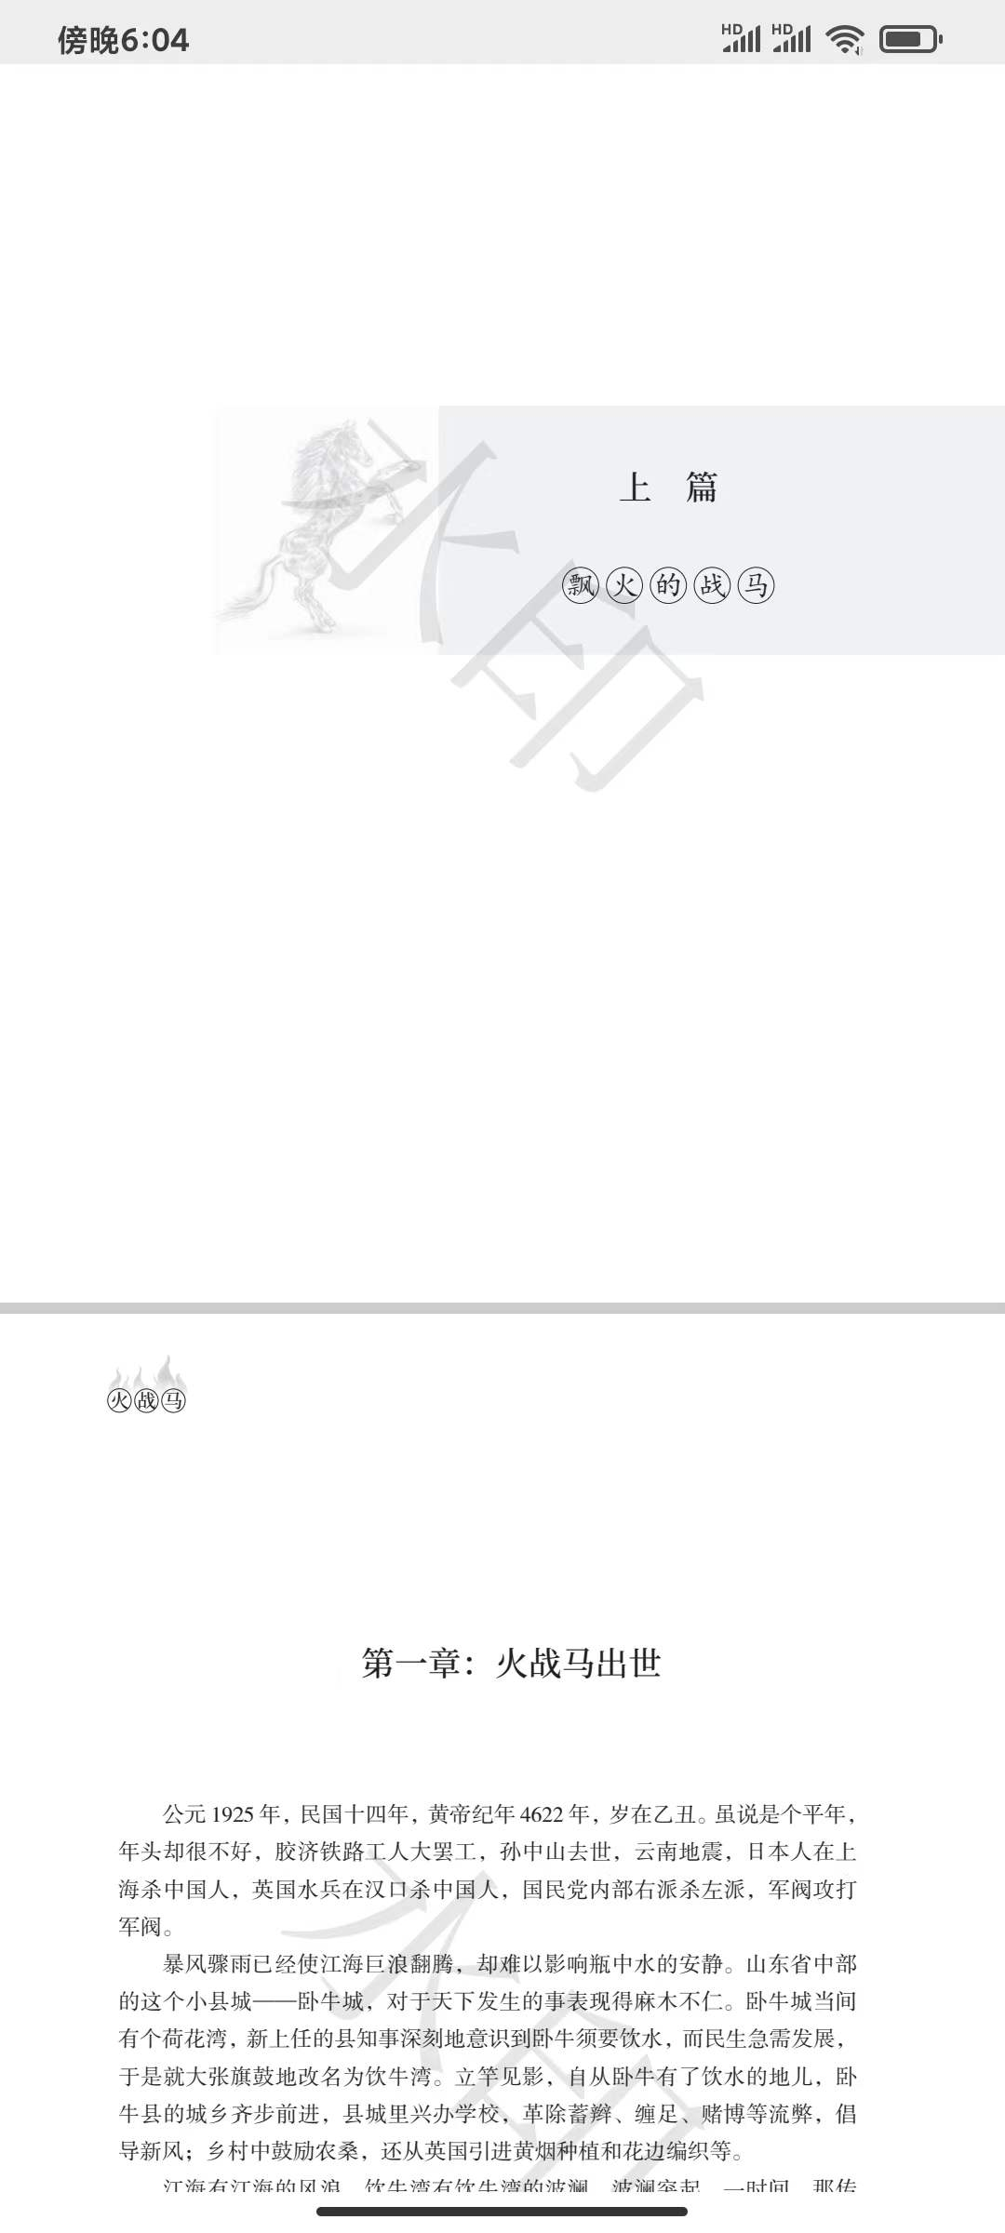

（长篇小说）

火战马

内容说明
故事简介
人物表

Fire Warhorse

Content Description
The legendary story of a famous Olympic figure, "Fire Warhorse" revolves around the "Joyful Way Institute Wei County Concentration Camp" and the war of resistance. It is a work of cultural exchange between China and the West, in line with the "11th Wei County Concentration Camp Topic" selection mentioned in the "Shandong Province's 14th Five-Year Plan Key Literary and Artistic Creation Project Collection Notice". The novel "Fire Warhorse" is a sequel to the Oscar classic movie "Chariots of Fire", continuing the saga of the same protagonist inspiring a group of people to run in China. Whether it be competitors running for achievements, the common people running for survival, or converts running for faith, the novel explores various motivations for running. In the film "Chariots of Fire", Eric Liddell's Olympic track opponent is his schoolmate, Abraham. The novel "Fire Warhorse", presents Liddell's counterpoint in the form of the barefooted mountain dweller, Liu Pao Shan. In the first case, the opponent keep pace side by side; in the latter, the opponent engages in a life-saving rescue. During the chaotic times of the Republic of China, a British Olympic champion who runs for God and a local barefooted mountain dweller who runs for immortals are both involved in gripping stories of righteous uprising against the Japanese invasion. Furthermore, there's a mysterious organization that initially targets but eventually comes to aid foreigners, and a warhorse marked by flames.

Having received top-notch university education but foregoing a promising career in his home country to serve in a less developed nation is a rare example. A single candle, though small in its power, can light a million others, bringing a great illumination out of the shadows. This sentiment is respectfully extracted from local historian Qu Zhengmin's (the late Chinese-American) "Great Loss of Good Teacher Li Ai Rui at Wei County Concentration Camp".

Story Summary
In the twilight years of the Qing Dynasty, a remarkable figure emerged in a remote mountain village, known as Liu Pao Shan—"Barefooted Immortal"—who ran through the wilds unrivaled, his bare feet growing only tougher against the rocks. As his fame soared, he encountered a foreigner, renowned as the world's premier runner. Born in China but raised in Britain, Eric Liddell (Chinese name "Li Ai Rui"), shattered the 400 meters world record at the 1924 Olympics and won the gold medal for Britain. After his victory, he gave up his champion status and comfortable lifestyle, decisively returning to impoverished China. In 1925, before taking up a teaching post at "New College", he practiced in a remote mountain village in Shandong Province. When these two top runners from different worlds met, a series of competitive events unfolded—a clash and eventual fusion of speed and endurance filled with contest, understanding, and friendship. The beacon of competitive sports shone, encountering panic, doubt, and acceptance. Western sports met Chinese tradition, kindling heat through friction and leading to events such as "The First Race in a Chinese Village", "The Sino-British Athletics Competition in a Small Town", "The Path of the Mean", and "Kua Fu Chasing the Sun".

Characters:
Main Characters:
Li Ai Rui: Local name "Li De Er", British, born in Tianjin in 1902, 1924 Olympic Champion — running for faith.
(Persona basis: Eric Liddell, British sprinter.)
Liu Pao Shan: A warrior from the mountainous countryside, the barefoot runner — running for survival.
(Persona basis: Liu Fengshan, leader of the "Nine-Lined Joint Resistance against Japan" from Xi Shi Village, Tai He Town, Zichuan District, Zibo City, Shandong Province.)
Fire Warhorse: Headmaster of a mysterious Taoist organization — running for ancient immortals.
Shin Bao: (Japanese) Infiltrating China under the guise of a businessman — running for the king.
Tian Mu Shan: Student leader of the "boycott Japanese goods" movement — running for radical ideas.

Secondary Characters:
Wang Xiao Si: Female knight, whose martial arts were passed down from the Fire Warhorse.
Pot Cover: Lay Taoist, who reveres the three teachings of Confucianism, Buddhism, and Taoism, and is adept at the five elements of yin and yang.
Wang Shan Zhou: Served as county magistrate and county leader, later simultaneously commanded the Nationalist Shandong advance army's 15th Column.
Security Team Leader: Head of the county security team, later special squad leader of the Nationalist Shandong advance army column.
Wang Bu San: Disabled soldier who became a bandit, fought in the Northeast after the Mukden Incident, later commanded the 4th Column of the Nationalist Shandong Guerrilla Zone.
Scorpion Lad: Expert climber, known for his extraordinary achievements.
Wang Zhang Gui: Father of Wang Xiao Si, from a martial arts family.
Tian Zhang Gui: Father of Tian Mu Shan, from a martial arts family.
Zhang Xing Tai: Excrement cleaner at Wei County Concentration Camp, a farmer from the outskirts of Wei County.
Old German: (German national) Clergy of the county church.
Huang Le De: A local villager who risked his life to fundraise for detained foreigners.
Wang Shao Wen: A local villager actively involved in the rescue of detained foreigners.
Yi Zuo: (Japanese Major) Administrator of Wei County Concentration Camp.

Foreign Detained Characters:
Dai Ai Mei: (Female) Born in 1932 at Song Men Guan in Kaifeng, Henan, later became a famous American author.
De Wei Si: Notable figure, clergyman.
He Shi: (Over 90 years old) President of North China Theological Seminary.
Lei Zhen Yuan: Once an adviser to Chiang Kai-shek.
Han Kui Te: Clergyman.
Heng An Shi: Escaped convict, born in June 1920 in Fenyang City, Shanxi Province, later (1981—1985) served as the American Ambassador to China.
Di Lan: Escaped convict, a retired British Navy Captain who worked for the British Tobacco Company before his capture.
Tony: Member of the concentration camp’s foreign running team, a follower of the Olympic champion.
Stephen: Recipient of Eric Liddell’s running shoes with six spikes, a member of the concentration camp’s foreign running team, a follower of the Olympic champion.
Joyce: (Female) Student (holder of Eric Liddell’s handmade teaching materials).

目录：

Table of Contents:

Introduction

Part One: The Roaming Horse of Fire
Chapter 1: The Birth of the Fire Warhorse
Chapter 2: The Appearance of the Fire Warhorse
Chapter 3: Running in the Mountains
Chapter 4: The Immortal Playing with Mud
Chapter 5: Trains, Warhorses, and People
Chapter 6: The Countryside without a Racetrack
Chapter 7: The Head of the Ancient Temple
Chapter 8: The Taoist Meets the Priest
Chapter 9: The Shepherd and the Sheep Slayer
Chapter 10: The Warhorse of Flames from Years Ago
Chapter 11: "International Competition" in the Mountain Gully
Chapter 12: Foreign Monks Entering Chinese Temples
Chapter 13: The Bandit Kidnaps a Foreigner
Chapter 14: "Three Questions of the Olympics" and Others
Chapter 15: Sounds Beyond the Strings
Chapter 16: A Pair of Barefoot War Shoes
Chapter 17: The Japanese Have Also Arrived
Chapter 18: A New Flower Erupts from the Grass
Chapter 19: Competing with a Kite
Chapter 20: The World Turns Out to Be a Globe
Chapter 21: The Fair Racetrack in Bandit Territory
Chapter 22: Fish Scale Albums
Chapter 23: The Sino-British Athletics Competition in the Small Town
Chapter 24: The Cross Building of the Joyful Way Institute Completion Ceremony
Chapter 25: Hammering the Stone Slabs of China
Chapter 26: Raiding Japanese Goods
Chapter 27: Armed Confrontation with Japanese Security
Chapter 28: County Magistrate's Head Injured and Bleeding
Chapter 29: The First Girl to Enter School
Chapter 30: The Middle Path of Running Tracks
Chapter 31: The Opera Facing the Audience
Chapter 32: The Chinese Shopkeeper in the Foreign Firm
Chapter 33: Tears Seeping from the Stones
Chapter 34: The Sports Field of Dalian
Chapter 35: Chinese-Styled Racing - The Pursuit of the Sun
Chapter 36: Divine Medicine in the Ancient Mountain Temple
Chapter 37: Observing "Great Feng Shui"
Chapter 38: Train Derailment Incident
Chapter 39: Blaming the Bandits
Chapter 40: Western Medicine and Divine Medicine
Chapter 41: Another Iron Spike on the Rails
Chapter 42: To Solve the Burial Mound, You Need the Burial Mound Person
Chapter 43: "Cause" and "Effect"
Chapter 44: Tianjin Civil Park Stadium
Chapter 45: The Foreign Grasshoppers Have Arrived
Chapter 46: Notices in Yellow Paper and Black Ink
Chapter 47: Methods of Relief Called "San Kai"
Chapter 48: County Magistrate Wang's Commendation
Chapter 49: The Last Two Families of "San Kai"
Chapter 50: The Hometown of the Warhorse of Flames
Chapter 51: The Intersection of Trajectories

Part Two: Rushing to the Concentration Camp
Chapter 52: The Stove of Immortals
Chapter 53: Great Exhibition of Asian Photography
Chapter 54: The Boiling Woniucheng
Chapter 55: Great Views of Wei County
Chapter 56: The Helm of the School
Chapter 57: Mr. Shin Bao
Chapter 58: The "Twelve Tombs" in the Mountain Village
Chapter 59: A Gush of Earth Fire Rising to the Sky
Chapter 60: The Grand View of the Joyful Way Institute
Chapter 61: The Great Sight of the Three Churches
Chapter 62: Sword Technique of the Boxers
Chapter 63: Salted Vegetable Banquet
Chapter 64: Life in the Wei County Enemy National Group
Chapter 65: A Delayed Chinese Wedding
Chapter 66: The Head Guard's Chinese Name is "Not Feasible"
Chapter 67: Committee for Self-Government of Overseas Chinese
Chapter 68: The Red Warhorse and the Black Warhorse
Chapter 69: A Pair of Running Shoes and Children's Shoes
Chapter 70: Hopes and Desires
Chapter 71: The Flower of Love Under the Whip
Chapter 72: Over 300 Children and the "Kanto Candy"
Chapter 73: A Wedding in the Concentration Camp
Chapter 74: A Chinese Farmer
Chapter 75: Broom Cannon
Chapter 76: A Heavenly Book
Chapter 77: A Mr. Huang Le De in Wei County
Chapter 78: Wang Shao Wen Persuading Commander Wang
Chapter 79: A Meeting of Life and Death
Chapter 80: Neutral Countries Intervene in the Concentration Camp Incident
Chapter 81: The Common Messenger Between Enemy and Ally
Chapter 82: Broom Cannon and Small Steel Cannon
Chapter 83: Running Before and After the Jailbreak
Chapter 84: A Commander Exchanged for Two Overseas Chinese
Chapter 85: Moses in the Concentration Camp
Chapter 86: British Prime Minister Named Exchange Personnel
Chapter 87: Plainclothes Spy Among Plainclothes Agents
Chapter 88: The Choice Between Faith and Freedom
Chapter 89: Dialogue Across the Night Curtain
Chapter 90: American Planes Fly Over Wei County
Chapter 91: American Machine Guns and Guerrilla's Hand Grenades
Chapter 92: Run, Those Bare Feet
Chapter 93: The Last Blast of the Broom Cannon
Chapter 94: The Final Repentance of the Warhorse
Chapter 95: Oh, the Warhorse with Flames Floating
Chapter 96: The Cunning Plan of the Anti-Japanese Advance Army
Chapter 97: Lieutenant Colonel Shin Bao Persuades County Magistrate Wang to Surrender
Chapter 98: Deciphering the Warhorse of Flames
Chapter 99: The Grave of the Warhorse of Flames
Chapter 100: The Stable of the Warhorse of Flames
Chapter 101: Home in Heaven - Heavenly Home

引言

开篇

上篇：飘火的战马

第一章：火战马出世

公元1925年，民国十四年，黄帝纪年4622年，岁在乙丑。虽说是个平年，年头却很不好，胶济铁路工人大罢工，孙中山去世，云南地震，日本人在上海杀中国人，英国水兵在汉口杀中国人，国民党内部右派杀左派，军阀攻打军阀。

Introduction
The earliest time a Chinese person won an Olympic championship can be traced back to the year 1924. In that year, France hosted the 8th Olympic Games in Paris, where the motto of "Citius, Altius, Fortius" (Faster, Higher, Stronger) was introduced for the first time. At that time, the land of China was still oblivious to competitive sports, let alone the Olympics. However, on the track of that Olympics, a Chinese appeared and won the championship in the 400 meters race. What's more, he broke the world record and retained it for eight years. He was Eric Liddell, unequivocally a Chinese person according to the principle of jus soli. Unfortunately, he competed for Great Britain, and the gold medal was accredited to Britain's tally. He became a national hero in Britain, enveloped in a halo of honor and piled with generous treatment. But he attributed all glory to God and firmly returned to China. He said, "China is the new racetrack that God has arranged for me," yet China had no tracks for running, and his return was not for the sake of racing. He came to China solely to be a chemistry teacher at the New College in Tianjin. At this time, "chemistry," much like "racing," was extremely rare in China, but the New College Middle School welcomed him. The church school mandated that he must intern in a remote and impoverished village for a period and write something akin to a personal reflection. Thus, arranged by the church, he journeyed to a distant village thousands of miles away. The world champion came as a missionary, but there were neither racetracks nor God here. His arrival was like a stone thrown into still water, a drop falling into boiling oil, a foreign object squeezing into the eyelid, leading to panic, explosion, and pain, and it also brought out the legendary horse of flames.

Opening
A bright moon hung high, shining upon the earth. It was the moon of the fourteenth year of the Republic of China (1925), and the earth was the plains of central and eastern Shandong Province. Under the moon, the earth was quiet and simple, but not truly so, as the moonlit villages and fields appeared like an ancient ink wash painting. It was also due to the moonlight that a straight, hard, and brand-new scar appeared on this ink wash painting, a scar that stretched across the entire canvas, extremely discordant and destructive of the original tone. This deep mark etched upon the earth was also deeply etched into the hearts of everyone in Shandong. In the minds of the people of Shandong, even in the minds of all the Chinese people, this mark was an element of disruption and a disaster. In the dead of the night, demons and ghosts are apt to appear, for it is when the gods are asleep. The moonlight may not dispel demons but can reveal them. Under tonight's moonlight, the revealed foreign object was man-made by foreigners, a foreign thing. This object was wrought of metal, forged by foreign blacksmiths. Foreign blacksmiths differ from Chinese blacksmiths, as the latter, with bellows and hammers, can forge tools of agriculture, whereas foreign blacksmiths can create this metallic expanse spanning thousands of miles. No local knew what kind of bellows or forges were used by these foreign blacksmiths, they only knew they must belong to the demons, and that their creations were demonic. What sort of demons? Under the moonlight on the plains, two parallel white rays stretched east to west, without visible beginning or end. It was a railway: two tracks, their surface reflecting white light under the nocturnal sky, stretching deeply into the darkness. There was a time when it was a thorn, piercing proudly into China's flesh, startling the sluggish and numb nerves of an ancient civilization. Now, this thorn has become a tube, relentlessly sucking the rich nutrients of the old country. Some say it is the foot of a sowing tool, inseminating this virgin land with seeds of the industrial revolution. The nation's people were incensed, but anger couldn't stop the "one's" further penetration, for each bout of fury only stimulated the other side's bestiality, leading to deeper incursion. At present, the "one" had penetrated deeply into the fertile body's hinterland - the prefecture of Ji'nan. What a road unseen by the people before! This road serves not man nor beast, only the centipede-like metallic contraption. The contraption is made up of a string of metal boxes, the boxes on metal wheels, the wheels sitting on the tracks. At the front is the locomotive, into which several people enter, and then black smoke billows from the locomotive's chimney, with its loud cries, running forward. It is said that the emperor did not fancy this object - both officials and commoners could sit in it, losing the privilege of ranks denoted by "the emperor in a six-horse carriage, princes in five, ministers in four, senior officials in three, scholars in two, and commoners in one", and thus also the divine authority was lost. Foreigners seduced with the idea that the train was tailor-made for the Qing Empire, don't you see - when the train starts, a long black braid would grow out of its chimney. This object is called a locomotive. The villagers found that the tracks were stationary, but the train was alive. They also discovered that the train was incredibly powerful, yet it could only run along the tracks, unlike donkeys that could go any road, could pull mills, could run all over the hills. A long and persistent whistle sounded, disturbing the sleep of the wild; the object that ran on the tracks was arriving. A train (steam locomotive) approached from afar, accompanied by uniform and forceful "clank" sounds, occasionally emitting a sharp cry, inconsiderate of the sleeping villages around, as if a band of brigands were entering a village with drums and gongs. The steam train, like a large centipede, followed those two shining rails. On both sides of the railway were dirt roads, parallel to the railway, reserved for the railway maintenance crew. The train was coming; a patrol officer, holding a signal lamp, moved away from the railway to the dirt road to let the train pass, waving the lamp towards the locomotive to signal safety, and the train responded with a whistle of acknowledgment. It wasn't courteous; it was part of the job, routine. Suddenly, something out of the routine happened: someone rushed onto the dirt road and began running after the train. The patrol officer hurriedly shouted to stop him and shone his signal lamp at the man, discovering that he was a robust person, a barefooted one to be precise. Assuming he was a "flying thief" specializing in train robbery, the officer gave chase. After running a bit, however, the patrol officer was out of breath, stopped to pant, and watched helplessly as the strong man followed the train into the distance. The patrol officer witnessed another abnormal sight - under the moonlight in the wilderness, a ball of flames emerged far away and quickly approached the speeding train. The ball of flames was a warhorse, draped in orange-red flames. On the horse's back, a black-clad warrior with a sword, its tassel fluttering in the wind. The galloping flame horse cut diagonally towards the train, then ran alongside it. On the plain, a train ran along two gleaming rails, a human runner to the right, and a galloping warhorse to the left, all three progressing in unison. They paralleled, converged, and separated at turns. The train driver saw everything clearly, was intensely affected, and pulled the whistle. The resounding whistle, the vigorous sound of the locomotive's wheels and connecting rods, became the theme music; the flames on the horse, the reflection on the rails, the headlights of the train served as stage lighting; with the suspended moon closely following, spotlighting the protagonists on the stage. This was a freight locomotive, but with two passenger cars hitched behind dozens of freight cars, incidentally catering to travelers. There were few passengers on the night train, among them two foreign missionaries, one very old, the other quite young. The older one was the senior priest of the county church, who had been in China for over thirty years, known to the faithful as "Old German"; the young one's reputation was great, especially great, as he was the top scholar at last year's (1924) World Sport Meet. At this moment, the old and the young witnessed the chase outside their window, each emphasizing different points. The young foreigner said, "In this rural area, completely unaware of competitive sports, it is unexpected and delightful to see such a fast runner." The older one said, "The flame horse! I saw it twenty-five years ago." The young one said, "A natural born runner! I must find him." The old one said: "Finding the flame horse is to find the suffering from twenty-five years ago."

Part One: The Roaming Horse of Fire
Chapter 1: The Birth of the Fire Warhorse
In the year 1925, the fourteenth year of the Republic of China, the 4622nd year of the Yellow Emperor's calendar, the Year of Yi Chou. Although it was a common year, the beginning of the year was by no means ordinary. There was a significant railway workers strike on the Jiaoji Railway, Sun Yat-sen passed away, an earthquake in Yunnan, Japanese people killed Chinese in Shanghai, British sailors killed Chinese in Hankou, the Nationalist Party's right faction killed leftists, and warlords attacked warlords.

