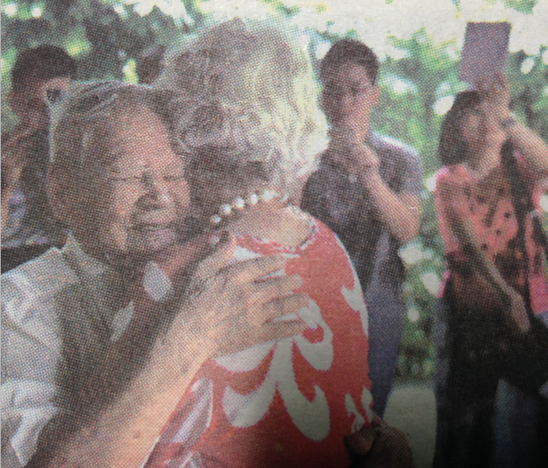
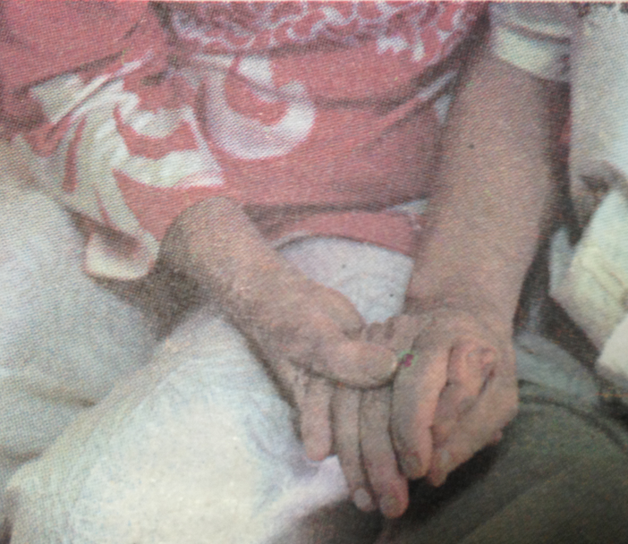
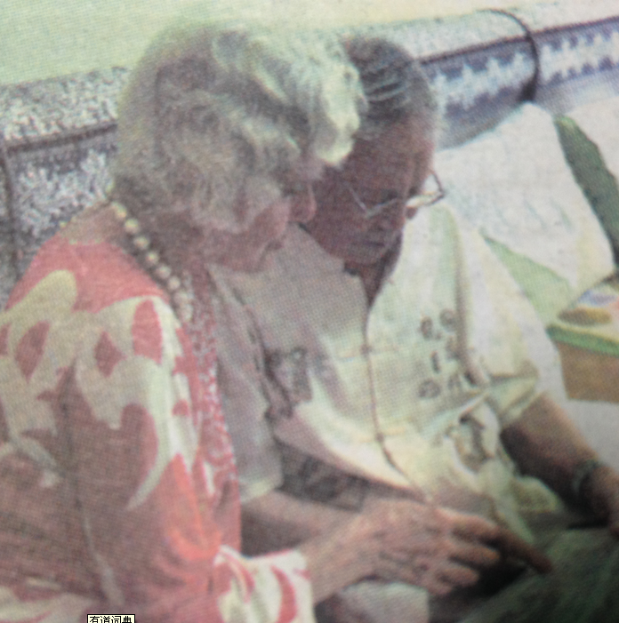

Mary and Wang hugging tightly at the first meeting 71 years later
Two hands holding
Reading together the 18 letters of gratitude

From New Jersey to Guiyang
71 Years Later, Mary Meets Her Liberator
Shot and reported by Liu Changmin

A transpacific finding and a meeting after 71 years. On July 27, Mary made a special trip from New Jersey to Guiyang, China to visit her benefactor --- Wang Chenghan, the Chinese interpreter of US “duck mission” in the World War II, who has been sought over 70 years by her.



Mary and Wang hugging tightly

From GUIZHOU METROPOLITAN DAILY

Visiting the “last hero” in her heart
On May 15, 2015, US “Retrospect” published the interview with Mary Previte in the front page titled “Seven Decades Later, Previte Connects with Liberator”.
In the interview, Mary recalled the rescue on August 17, 1945, when she was imprisoned in Weihsien (now Weifang, Shandong Province) Concentration Camp. It just happens that Wang Chenghan’s grandson, Wang Qian, is in America engaged in photography and he knows his grandfather is looking for the other members of “Duck mission”. Wang Qian contacted with Mary by E-mail. At last, on May 3 of previous year, a transpacific call conected American Mary and Guiyang Wang Chenghan.
“Finding someone named Wang in China is as difficult as finding someone named Smith in the United States”, Mary said, “a 90 years old man is healthy and has excellentmemory; and I am still familiar with his English”.
One more year later, Mary, regardless of the age of 83, decided to go to China to visit the last hero in her heart.

Affectionately tight hugging years later
At 15:20, July 27, the reporter from Guizhou Metropolitan Daily came to Wang Chenghan’s home located in Baoshan Nanlu, Guiyang.
At 15:45, the phone at Wang’s home rang. “It must be Mary coming”, Wang who had long been waiting, shouted. The voice on the phone told Wang that Mary had come to the neighborhood where Wang is living directly from the airport and was waiting downstairs.
Wang, excited beyond words, rushed downstairs. When downstairs, a grey-haired old lady in red blouse and white pants, staring eagerly at the stairway came into his sight immediately. “You are my hero, you are the last hero in my heart”, Mary shouted excitedly the moment she saw Wang.
Meanwhile, Wang, already 91 years old but still vigorous, walked speedily to Mary. They, once thousands of thousands of miles apart, now hugged tightly each other for a long time as if with no intention to separate.
“I’m very happy that finally in Guiyang, China I can see my Chinese hero who liberated me. It’s unbelievable to find Eddie Wang in China with such a large population”, said Mary, holding Wang Chenghan’s hands tightly.
Also holding Mary’s hands, Wang Chenghan, in fluent English, told Mary how he missed the other members of the Duck mission and how he missed Mary and her family for so many years.

Singing the song together “You Are My Sunshine”
Mary lived in Shandog province with her parents, both of whom were preachers. After the occupation of Jiaodong peninsula by the Japanese, Mary, with her sisters and brothers, four of them, and their grandfather were imprisoned in the concentrate camp in Weihsien. The inhuman life in the camp made Mary cherished the hope that they would be rescued by some heroes some day in the near future.
On August 17 in 1945, a B-24 plane hovered over the camp and six Americans and one Chinese interpreter parachuted to the camp at the risk of lives. They were the Duck mission members, with the mission to liberate aliens imprisoned by the Japanese. Mary, then 12 years old, and other children followed the mission members admirably everywhere. The mission members brought them chewing gums, candies and other supplies.
After the rescue, Mary left Weihsien with her sisters and brothers by air. But she was so excited that she forgot to say thank you to the heroes, which had become something that she regretted ever since.
At 15:53, after the short but exciting meeting, Wang invited Mary to his home. Sitting in the spacious living room, Mary could not wait to ask Wang many questions that she had expected to for years.
“How did you join the army?” asked Mary.
Wang Chenghan told Mary that when he was 18 years old in 1943, he entered Sichuan University, majoring in physics. It was such a critical period of the anti-Japanese war that he ceased his study, and went to Luzhou. It was there that he joined the army for the young of National Revolutionary Army. On April 25, 1945, he graduated from the training class for interpreters. In May the same year, he went to the interpreter pool in Kunming, and soon after that he was recruited by OSS (Office of Strategic Services).
“And how did you come to the rescue team?” asked Mary, eagerly to know all the answers that she had long been expecting to.
Wang said that although Japanese announced surrender on August 15, 1945, quite a few military forces did not admit defeat, and possibly they would be wild for revenge to the aliens imprisoned in the camps. With that, OSS set up several rescue teams because there were several camps in China. All the teams were named with the name of birds. The one in which he was in was named Duck mission. On August 16, the Duck mission was sent to Xi’an. And early the next morning, they went to the airport to fly to Weihsien with the mission to liberate the aliens in the camp.
“Do you still remember the song “You Are My Sunshine” you and your members taught us?” Without waiting for the answer, Mary could not help singing. “Of course” was the answer from Wang who also sang the song synchronizing with Mary.
In the warm and animate atmosphere, their synchronizing singing was so moving, so touching and so unforgettable. “You are my sunshine, my only sunshine. You made me happy, when skies are gray. You never know dear. How much I love you. Please don’t take my sunshine away”.

Always remembering you jumped down suddenly from the plane over the Weihsien sky
Mary told Wang that 18 former survivors of the camp entrusted her with letters of thanks to Wang when they knew Mary would call on Wang in China.
Pamela Flynn, 90 next year in California said in her letter:
Dear Eddie Wang,,
I will be 90 on my next birthday. If you and your brave comrades hadn’t saved us, I would probably have died before I reached nineteen. Thank you for giving me seventy more years of living here on earth with all the wonderful people who touched my life along the way. It goes without saying --- you head that list of friendship. Your kindness and bravery will never be forgotten.
The other 17 letters also expressed their thanks to Wang.
The letter of Stephen Sweeney, senate president of New Jersey Senate says as follows:
Dear Mr. Wang,
On behalf of the people of the state of New Jersey State Senate, I would like to take this opportunity to personally thank you for your actions and heroism during the World War II.
The remarkable story and liberation of the Japanese-held Weihsien concentration camp in China on August 17, 1945 was recently brought to my attention by Mary Previte, a prisoner of the camp. Mary and the 1,500 allied civilian prisoners, their families and their descendants, will never forget the actions of a seven-man team that parachuted into China and secured the camp and its prisoners for rescue.
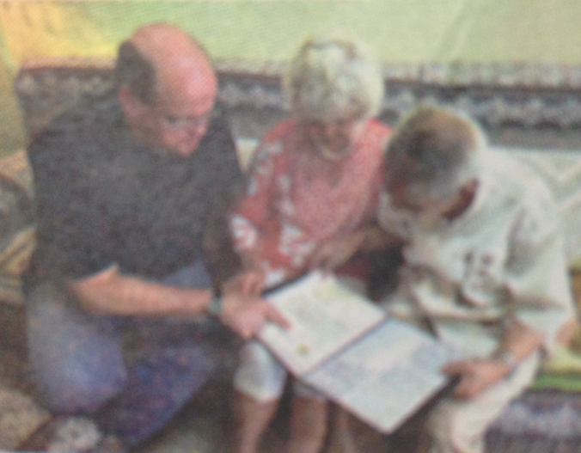
Your bravery as the lone Chinese interpreter and the youngest man of the team are deserving of the highest commendation and praise. You brought an uncommon level of knowledge and respect for others to “Operation Duck”, which contributed to the outstanding success of your mission and built an enduring bond between you and your American partners. Your personal sacrifices, commitment, and efforts exemplify the tenacity of the human spirit and serve as a beacon of hope and freedom for the prisoners of Weihsien.
Delivering the letter of gratitude from American ambassador
Once again, I extend my deepest gratitude and appreciation. I wish you and your family continued good health and happiness.
Furthermore, the incumbent ambassador to China, Max Baueus sent forth his letter of thanks as well. He said, after he heard about the extraordinary service of Wang, he did offer his thanks for Wang’s help to American citizens in Weihsien camp and welcomes Mr. Wang to meet him in ambassador, if possible to Beijing. #

